NAME: The Australian Constitution
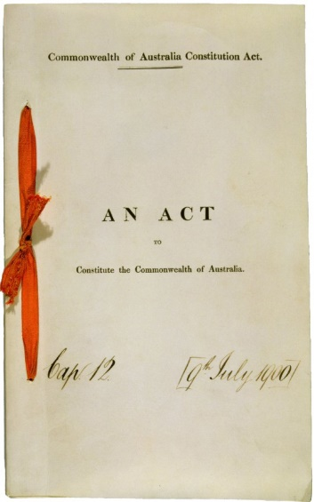
What is a constitution?
A national constitution is a set of rules for governing a country. Such rules may be based on tradition (unwritten) or may be written down in the form of a law or number of laws. In some countries laws forming the constitution are ordinary laws which can be changed just like any other law, but in most countries the laws forming the constitution have a special status.

What does the Constitution do?
The Australian Constitution was an agreement under which the former British colonies came together as States in a federation. The Constitution establishes the form of the federal government and sets out the basis for relations between the Commonwealth and the States.

Features of the Australian Constitution
The Australian Constitution is a written constitution and is divided into 8 chapters and 128 sections. Key features of the Constitution include:
- A federal parliament and government, responsible for national decision-making and law-making.
- A bicameral Parliament, including the Queen (represented by the Governor-General), the Senate and the House of Representatives.
- Six state governments, responsible for state matters.
- Power-sharing arrangements between the federal and state parliaments.

- The High Court of Australia, which is the final court of appeal. The High Court interprets the Constitution and decides its meaning, as well as, settling disputes between the federal and state governments.

Chapters of the Australian Constitution
Chapter and description | Area of Focus
Chapter 1-the Parliament | Describes the composition and powers of our federal Parliament, which consists of the Queen and a bicameral legislature.
Chapter 2-the Executive Government | Describes the power of the most formal elements of Executive Government, including the Queen, Governor-General and the Federal Executive Council.
Chapter 3-the judicature | Provides for the creation of federal courts, including the High Court of Australia.
Chapter 4-finance and trade | Deals with finance and trade matters.
Chapter 5-the states | Outlines the federal relationship between the Commonwealth, and the states and territories. Outlines how federal law overrides state law. Gives the federal Parliament the power to override a territory law.
Chapter 6-new states | Deals with the creation of new states and gives the Commonwealth power to make laws for the government and representation of the territories.
Chapter 7-miscellaneous | Describes where the capital of Australia should be and the power of the Governor-General to appoint deputies.
Chapter 8-alteration of the Constitution | Describes how the Constitution can be changed by referendum.


What is a constitution?

List 5 features of the Australian Constitution

List each chapter of the Australian Constitution and include its description.

